Analysis of Algorithm Efficiency

Outline:

2.1- run time and algorithm speed

2.2- three notations: bigO, big omega, big theta

Measuring an input’s size:

* Larger inputs mean longer run time in almost all algorithms.
* Input size is the size of list
* If input type is changing the size then assign “n” to size
* If input size is non changing (phone number) then input size is constant size
* Distinguish between worst-case, average case, and best case

Units for Measuring Run Time:

* One approach: count number of function executions.
* Better approach: identify most important operation (basic operation) compute number of times basic operation is executed.

Binary search:

Divide half the portion of the list that could contain the item. Repeat this process to narrow down to one possible solution. log2n run time.

Pseudo code:

1.Let min = 0 and max = n-1.1.If max < min, then stop: target is not present in array. Return -1.

2.Compute guess as the average of max and min, rounded down (so that it is an integer).

3.If array[guess] equals target, then stop. You found it! Return guess.

4.If the guess was too low, that is, array[guess] < target, then set min = guess + 1.

5.Otherwise, the guess was too high. Set max = guess - 1.

6.Go back to step 2

Python code:

Big- θ (Big Theta) notation:

When we say that a particular running time is Θ(n), we're saying that once n gets large enough, the running time is at least k1\*n and at most k2\* n for some constants k1 and k2. Here's how to think of Θ(n)

Big-O notation:

If a running time is O(f(n)), then for large enough n, the running time is at most k \* f(n) for some constant k. Here's how to think of a running time that is O(f(n)):

Big- Ω (Big-Omega) notation:

If a running time is Ω(f(n)), then for large enough n, the running time is at least k⋅f(n) for some constant k. Here's how to think of a running time that is Ω(f(n))

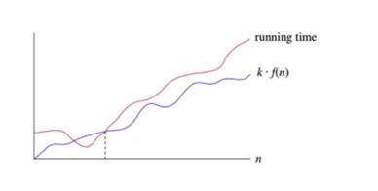

If you have a function f(N):

Big-O tells you which functions grow at a rate >= than f(N), for large N

Big-Theta tells you which functions grow at the same rate as f(N), for large N

Big-Omega tells you which functions grow at a rate <= than f(N), for large N